Origami Boat!

- Start with your rectangular paper, orient it vertically, with the long edges going up and down. Fold the bottom half up to the top. Fold the bottom right corner over to the left corner and make a small pinch, just enough to crease the paper. Open it back up.
- Using the crease as a guide, fold the left and right bottom corners up and to the middle. Flatten the folded pieces down. Rotate the paper. Fold one layer from the bottom up along the bottom of the front flaps.
- Flip the paper over to the other side. Fold the bottom edge up in the same way. Unfold, and then fold the bottom right corner in along the crease you made. Repeat on the bottom left flap.
- Re-fold the bottom edge back up. Open the bottom of the model. Look at the corners. Flatten and then insert the overlapping flap on the left underneath the right section.
- Fold one layer up to the top. Repeat on the back. Open the bottom of the model.
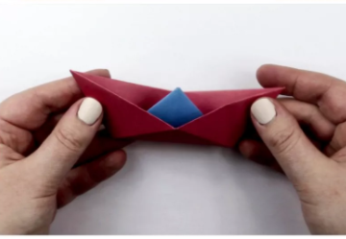
- Pull apart the left and right flaps. Flatten it out, in the shape of a boat. Open it slightly. The triangle in the middle resembles a sail.

